H30 2 LAN 4 COM Industrial PC
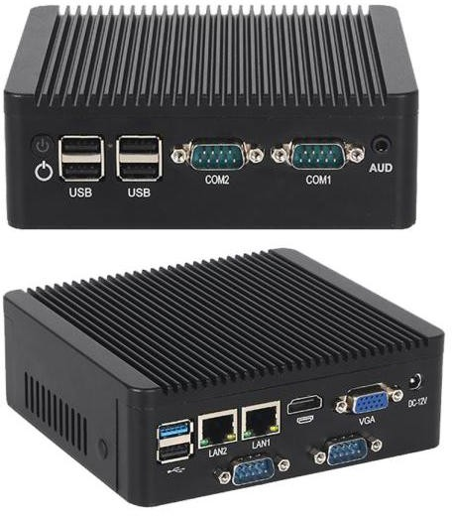

Features:
- Onboard with intel N2840/J2900 CPU;
- Support DDR3 SODIMM, Max Up to 8GB;
- 4*RS232 COM
- 2*RJ45 LAN Gigabit Ethernet;
- Fanless and low power consumption.

Specification of Motherboard

Model | H30 N2840/J2900 2 LAN 4 COM
Dimension | - 136*126*46mm  - Motherboard size：121.6*121.6mm
Processor | - Intel® Celeron N2840/J2900 Processor
RAM | - 1*SO-DIMM DDR3L 204 Pin Memory Slot  - Max support 8GB
Expansion | - 1 x MiniPCIe，support Wifi/4G Module
Front/Rear Interface | - 1 x DC-IN Power IN  - 1 x HDMI  - 1 x VGA  - 5 x USB2.0  - 1 x USB3.0  - 2 x LAN  - 1 x Audio  - 2 x COM  - 1 x HDD_LED  - 1 x PWR Power Buttom
Inbuilt Interface | - 1 x SATA slot  - 1 x SATA_PWR slot  - 1 x GPIO Pin Optional COM3/4 Pin  - 1 x F_PANEL  - 1 x DC_IN Pin
BIOS | - AMI BIOS
Power Management | - Supports Advanced Power Management (ACPI)  - Supports network wake-up for S3, S4, S5, and power-on startup, etc
Display | - VGA + HDMI, support synchronous/asynchronous dual display
Ethernet | - 2 x Realtek Gigabit LAN（RTL8111H）
Audio | - On-board ALC897 audio decoding controller Integrated power amplifier, 2W@4Ω

I/O Chipset | - IT8786E
Power | - DC/4Pin ATX Power supply
Working Environment | - Working Temperature：0℃~60℃  - Humidity：0%~95%
OS | Windows 7 / Windows 10/Linux

- Motherboard Layout Diagram
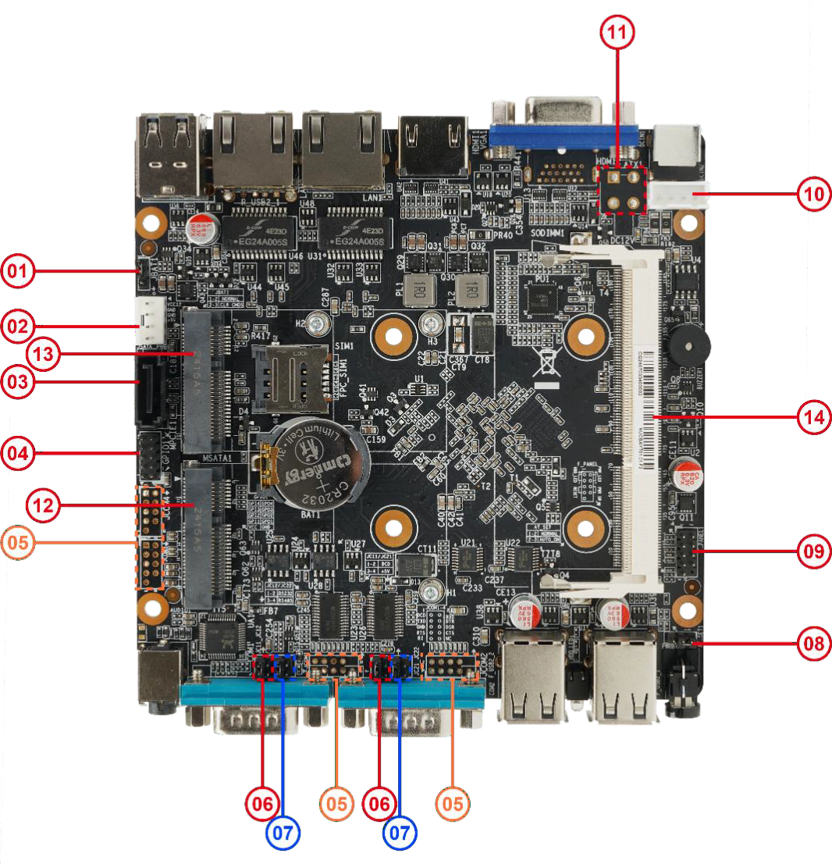
The illustration is for reference only, please refer to the real thing.

Ltem |  | Description
1 | JBAT1 | Inbuilt COMS Pin
2 | SATA_PWR | SATA Power Slot
3 | SATA | SATA Slot
4 | GPIO | Inbuilt GPIO Slot
5 | COM1/2/3/4 | Inbuilt COM Pin
6 | JC11/21 | COM1/2 hot-plug capable select jumper
7 | JC12/22 | COM RS485 select jumper
8 | AT_SET | Auto-power-on select jumper
9 | F_PANEL | Power Switch Pin
10 | DCIN | Power Supply Pin

11 | ATX1 | (Optional) 4-pin ATX power socket
12 | MSATA | mSATA slot
13 | MPCIE | mPCIe slot
14 | SODIMM1 | 1x SO-DIMM DDR3L memory slot

Interfaces
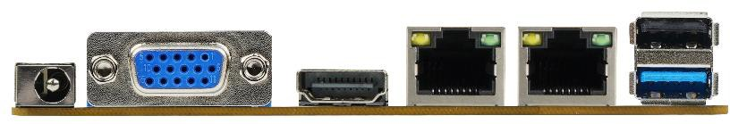
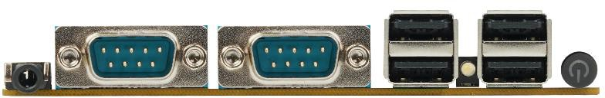

Item | Description
DC_IN | 12V Power IN
VGA | Display Port(Optional HDMI)
HDMI1 | Display Port
LAN | Link LED: green long light, indicates network connected
 | Active LED: orange blinking, indicates data transmission
R_USB3_1 | USB2.0+USB3.0
Audio | Audio Poer
COM1 | Serial Port 1 (configurable as COM header)
COM2 | Serial Port 2 (configurable as COM header)
F_USB2_2 | 2*USB2.0
HDD_LED | HDD Activity LED
F_USB2_1 | 2*USB2.0
PWRBTN1 | Power Button

